**Visualization of Novel Electronic Structures in Topological Quantum Matter**

**Yulin Chen**

***Physics Department, University of Oxford***

The discovery of materials with novel properties is one of the most fascinating aspects of physics, and such findings have always played important roles in the development of science and human life. A very recent example of conceptually new materials is the topological insulator. On the face of it, these are well-known, off-the-shelf materials, but they have previously overlooked properties which distinguish them from all other previously known quantum states. In its pure form, a topological insulator has a full energy gap in the bulk; while on the surface, it has massless and gapless metallic states formed by an odd number of relativistic Dirac fermions with helical spin texture. Within the last few years, topological insulators have grown as one of the most intensely studied fields in condensed matter physics due to their scientific significance and technological potentials.

The rapid development of topological insulators has also inspired the study of many other novel topological quantum states, such as quantum anomalous Hall states, topological semi-metals, and topological superconductors.

In this talk, I will show that by investigating these novel topological quantum materials with angle-resolved photoemission spectroscopy (ARPES), we were able to directly visualize their non-trivial electronic structures and unusual dynamics. In addition, I will briefly discuss the application potentials of these unusual materials, in electronics, spintronics and energy-related applications.

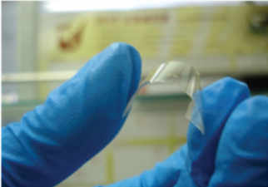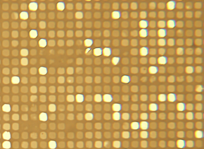

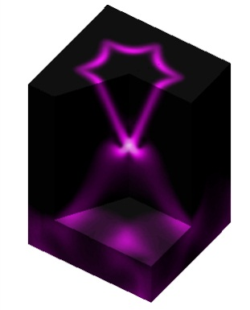

时间：12-24， 10:30

地点：物理系三楼报告厅