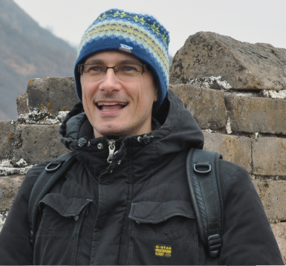学术报告

报告题目：Higgs boson couplings beyond the Standard Model

报告人：Professor **Aldo.Deandrea**

Institute de Physique Nucleaire de Lyon

报告时间地点：2012年12月6日（星期四）下午15：30，理科楼四楼会议室

报告摘要：  
I discuss the Higgs boson decay processes and its production, and provide a parameterisation tailored for testing models of new physics beyond the Standard Model. I also compare the formalism to other existing parameterisations based on scaling factors in front of the couplings and to effective Lagrangian approaches. At present only simple parameterisations with a limited number of fit parameters can be performed, but this situation will improve with the forthcoming  
experimental LHC data. Detailed fits can only be performed by the experimental collaborations at present, as the full information on the different decay modes is not completely available in the public domain. It is therefore important that different approaches are considered and that the most detailed information is made available to allow testing the different aspects of the Higgs boson physics and the possible hints beyond the Standard Model.

报告人简历：

1991-1995 Ph.D. at the university of Geneva with a thesis on “Effective lagrangian for the analysis of a strong interacting sector of electroweak symmetry breaking" (supervisor Prof. R. Gatto).

1991-1995 Assistant at the Department of Theoretical Physics of Geneva University.

1995-1996 \Assistant-docteur" at the Department of Theoretical Physics of Geneva University.

1996-1998 \Marie Curie" post-doctoral fellowship of the European Commission at the Center of Theoretical Physics of CNRS Luminy.

1998-1999 Research Associate at the Theoretical Physics Institute of the University of Heidelberg.

1999-2000 Fellow at CERN Theory division.

Since 2000 Professor at the University of Lyon 1.

2004-2009 Director of the IPNL Theoretical Physics Group.