真空技术讲座
High Vacuum Technology introduction：
Technology and Application of Vacuum Pump
Abstract:
In this talk, we will discuss some latest UHV technologies including:
Floating Suspension technique for turbo pumps
StarCell ion pump technology and 4UHV multichannel ion pump controller
low noise scroll technology .The applications and the features of the new
technology will also be presented in detail.
日期 :2014年6月11日(周三)
下午2:00-5:00
地点:北京大学物理系中楼312
邀请人：王新强 联系电话：62767150
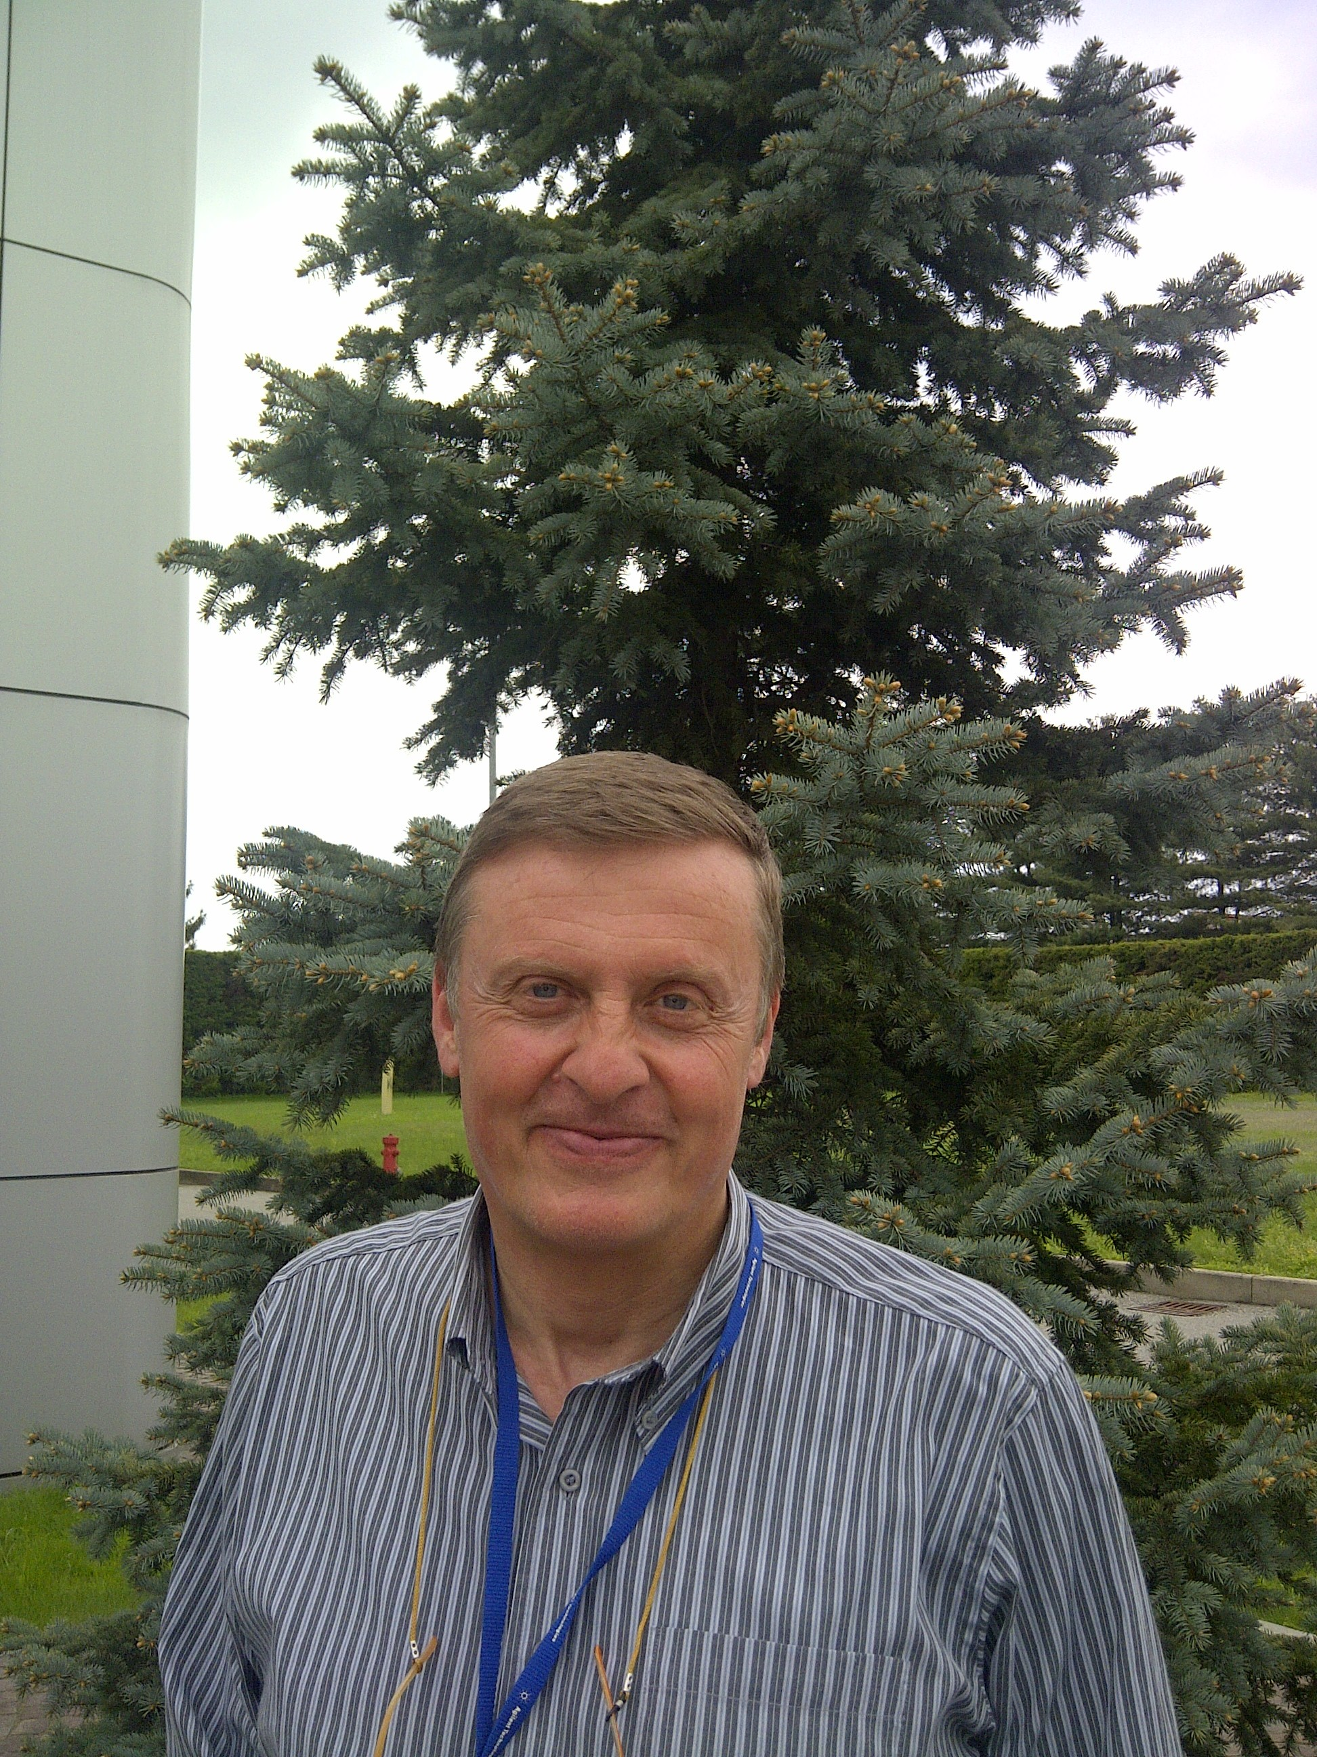
Speaker: Mauro Audi, Global Marketing Manager, Agilent Technologies
Mauro has been engaged in vacuum technology for 29 years and involved
in researching and developing different types of turbo pumps and ion pumps
in Varian Company. He is very experienced in the application of turbo pump
and ion pump in UHV systems. He has more than 10 international
conference papers on vacuum pump.

